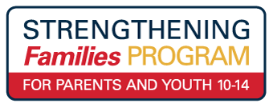
ENROLLMENT FORM - FALL 2021
Please check one: _____Greenville/BLWC Class- Tuesday Nights _____Grove City/AHN Class- Wednesday Nights Nights
Greenville Class-Tuesdays

Youth Name: _____________________________________ Age (must be 10-14): ___________
Parent/Caregiver Name: ____________________________Relationship to Youth: ___________
Other Parent Caregiver attending: ____________________ Relationship to Youth: __________
Parent/Caregiver Mailing Address: _________________________________________________
Parent/Caregiver Phone #:________________________________________________________
Sibling (that is age 10-14) attending: ____________Age___ Relationship to Youth: ___________
Sibling (that is age 10-14) attending: ____________Age___ Relationship to Youth: ___________
Sibling (that is age 10-14) attending: ____________Age___ Relationship to Youth: ___________

Childcare Needs: Please list those under age 10 who will attend childcare classroom:
Name: ___________________ Age _____
Name: ___________________ Age _____
Name: ___________________ Age _____

Enrolling/Referring Agent, if applicable, OR check “self”: Self: _____ (please check)
Organization: ___________________________________ Staff Name: ___________________
Phone #: _____________________ Email address: __________________________________
School District Youth attends: _____________________________________Grade Level: _____
Classroom Accommodations Needed: _____________________________________________________
Medical Concerns: _____________________________________________________________________
Behavioral Concerns: ___________________________________________________________________
Food Allergies: ________________________________________________________________________

