Intercom Announcements
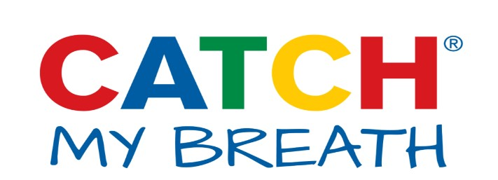
Intercom Announcements for Red Ribbon Week and Other Tobacco/Substance Abuse Awareness Events
The following intercom announcements were designed to be read by students in grades 5-12. They address social norms, health hazards, deceptive advertising, and commonly-held myths related to e-cigarettes. These can also be used as templates for your staff or students to create their own that might resonate more with the young people at your schools.
We suggest having a student or two read the script over the intercom announcements at the beginning and/or end of the day. If possible, review the announcements with the students before reading them on the air to ensure they can pronounce all of the words and understand what they are saying.

Announcement #1:
And now, let me CATCH My Breath, and spill some facts about e-cigarettes.
Big tobacco companies have paid for the hype you hear about e-cigarettes. That celebrity you see blowing puff clouds? Yep— bought and paid for.They want you to think e-cigarettes are fun, and harmless, but being addicted to nicotine is not cool.
Oh, and those e-cigarette flavors? Candy-flavored addiction? Not for me, no thanks. Don’t believe the hype.

Announcement #2:
And now, let me CATCH My Breath and spill some facts about e-cigarettes.
E-cigarettes claim to be harmless, but their ingredient list is like a bad chemistry experiment.
- Propylene glycol (pro-puh-leen gl-eye-call)
- Diacetyl (die-a-see-tall)
- Formaldehyde (for-mal-duh-hide)
- Acrolein (a-crow-lee-in)
- Nicotine (nik-oh-teen)
Sounds like toxins with a side of addiction to me. Who wants to pay for fruity flavored toxins? Not me, I'd rather keep my lungs toxin free.

Announcement #3:
And now, let me CATCH My Breath and spill some facts about e-cigarettes.
Have you seen videos online of people using e-cigarettes? Those videos are advertisements, bought and paid for by e-cigarette companies.
They’re trying so hard to make e-cigarettes look cool. They call it vaping, but that’s not vapor. It’s an aerosol (air-oh-sol)—a spray—of chemicals and nicotine that go deep into the lungs.
They must not think we’re very smart, like we wouldn’t check the facts. Someone should tell them, we won’t be fooled. There’s a reason why a whopping 87% of teens don’t use e-cigarettes regularly. Don’t believe the hype!

Announcement #4:
And now, let me CATCH My Breath and spill some facts about e-cigarettes.
E-cigarette companies think they are geniuses. They think if they cover the nasty taste of nicotine and toxins with candy and fruit flavors, that we won’t notice. Some of these toxins are known to cause cancer!
And you can’t just read the ingredient list. E-cigarette companies are behind on following FDA regulations for e-cigarette ingredient, manufacturing, and purity standards.
Do you really want to inhale grape-flavored toxins? No e-liquids are cool -- they’re an addiction tool. I don’t know about you, but I won’t be fooled.

Announcement #5:
And now, let me CATCH My Breath and spill some facts about e-cigarettes.
It’s true that e-cigarettes have fewer toxic chemicals than cigarettes, but they are still HARMFUL . 99% of e-liquids sold have nicotine – and with nicotine being highly ADDICTIVE, I wouldn’t exactly call it a healthy choice.
The flavors you find in e-liquids are FDA-approved for eating—not to heat up and breathe into your lungs.
E-cigarettes are illegal for teens to purchase and use for a reason - addiction potential. With highly-addictive nicotine and cancer-causing chemicals, it’s a candy-flavored recipe for disaster. As for me? I’m good without it.

Announcement #6:
And now, let me CATCH My Breath and spill some facts about e-cigarettes.
E-cigarette advertising companies have computer models and algorithms (a-log-rith-ms) that predict kids are easy targets, so they try to make it seem like everyone is using e-cigarettes all the time. I don’t know about you, but I don’t take orders from computers.
Social media is full of people who are paid to make e-cigarettes look fun, harmless, and cool. Being addicted to nicotine isn’t my idea of fun. We’re a lot smarter than these advertisers or computers think we are.

Announcement #7:
And now, let me CATCH My Breath and spill some facts about e-cigarettes.
E-cigarette companies are getting more creative in the way they get you hooked. One of the latest examples is a JUUL (joo-ul). E-cigarette companies will try to sell you that this e-cigarette can fly under the radar so you can sneak it into school or trick your parents and teachers. Don't believe the hype; these e-cigarettes contain high levels of nicotine and are still harmful. They aren’t worth the trouble!

Announcement #8:
And now, let me CATCH My Breath and spill some facts about e-cigarettes.
E-cigarettes contain toxic chemicals including nicotine which is not only harmful to a developing brain like yours, but a highly addictive substance!
Some negative consequences of using e-cigarettes include:
- Nausea, dry mouth, dizziness, coughing/wheezing.
- Triggers and worsens asthma
- Aerosol contains toxic chemicals that can damage the lungs.
- Long-term addiction (affects the brain)
- Ingesting e-liquid can be FATAL
Please - respect your body.

