**Grades 9-12**

**Physical Education Supplement**

This PE supplement is an addition to CATCH My Breath that was designed to reinforce learning objectives in an active physical education setting. The following activities are intended to be used for grades 9 to12 in addition to CATCH My Breath classroom sessions. The program can be taught at anytime of the year, however you may consider implementing the program in the fall during school-wide tobacco, alcohol and drug awareness campaigns. This supplement can also be used and adapted to a traditional classroom setting if desired and time permits.

It is recommended that the CATCH My Breath PE Supplement be used in successive PE periods until each activity is completed. Each activity is meant to be taught in the order presented. Although PE class times vary at each campus, the PE Supplement was designed on a weekly 50-minute class and the following sequence is suggested:

* Week 1: Activities 1, 2, and 3
  + Recommended to be taught in conjunction with CATCH My Breath Session 1
* Week 2: Activities 4, 5, and 6
  + Recommended to be taught in conjunction with CATCH My Breath Session 2
* Week 3: Activities 7, 8, and 9
  + Recommended to be taught in conjunction with CATCH My Breath Session 3

**Activity 1: Walk and Talk Warm Up**

**Estimated time:**5 minutes

**Materials:**None

**Organization**: Students walk the perimeter of the gym in pairs.

**CASEL Competencies Covered**

* Relationship skills - communication, social engagement, relationship building, teamwork
* Self-awareness - identifying emotions, accurate self-perceptions
* Social awareness - perspective-taking, respect for others

**Teacher Preparation: None**

**Description:**

1. As students enter the gym, greet them at the door and ask them to put their belongings away, then begin walking the perimeter of the gym.
2. When all the students are in the gym, tell them to quickly find a partner and walk the perimeter of the gym.
3. Ask the students to share with their partner either:
   1. What they know about e-cigarettes or
   2. A question they have about e-cigarettes as they walk the perimeter
4. Tell the students to take a seat, and then have a few volunteers share what they know or share a question they have about e-cigarettes.
5. Correct any misconceptions, such as:
   1. Nicotine is harmless
   2. Not all e-cigarettes contain nicotine
   3. E-cigarettes produce harmless water vapor
   4. E-cigarettes are not addictive
   5. E-cigarette contains harmful chemicals

**Activity 2: Consequences Abound**

**Estimated Time:**25-30 minutes

**Materials:**

* Whistle

**Organization:**Students will get toe-to-toe with a partner and exchange one health and one social consequence of using e-cigarettes.

**CASEL Competencies Covered**

* Social awareness - perspective-taking, respect for others
* Relationship skills - communication, social engagement

**Teacher Preparation:**

1. **Prepare** and display a white board or butcher paper with the following:

* **Health consequences**
  + Aerosol has toxic chemicals that can damage the lungs: arm pumps (pump both of your arms over your head). Hacks your brain (dopamine reward system, impulse control center): high knees
  + Nicotine causes addiction: standing oblique crunches (stand up with your heels together and your toes pointed outward. Extend one arm straight up above your head and place the other hand on your waist for balance. Bring your elbow and knee together, then return to the starting position)
  + Dry mouth, Vapor tongue, Sore throat, Nose bleed: calf raises (raise heels off the floor, then slowly lower them)
  + Nicotine toxicity: nausea, headache, increased heart rate: wall push-ups
  + Can be fatal for babies (SIDS, stillbirth, low birthweight): march in place
  + Batteries explode: squats
  + Gateway to combustible tobacco, alcohol and marijuana and other addictive drugs: hop in place
  + Ingesting e-liquid can be FATAL: jumping jacks
* **Social consequences**
  + Costs a lot of money, about $50 to get started:  jumping jacks
  + Cartridge pods cost $3- $7 (per pod):  hop in place
  + Get suspended from sports/school: squats
  + Bad role model to younger family members:  calf raises (raise heels off the floor, then slowly lower them)
  + Get in trouble at school or at home: march in place
  + Get in trouble with the law (Purchasing or possession is against the law under 18 or 21 depending on state): standing oblique crunches (stand up with your heels together and your toes pointed outward. Extend one arm straight up above your head and place the other hand on your waist for balance. Bring your elbow and knee together, then return to the starting position)
  + Lose the trust of parents: arm pumps (pump both of your arms over your head)

*Note to teachers: It is okay to modify these activities to fit the physical ability of your students or a skills unit in your class (e.g. volleyball or basketball skills drills, etc.)*

**Description:**

1. **Explain:** E-cigarettes are not harmless and have lots of health and social consequences associated with using them.
2. **Instruct** students to find a partner and get toe-to-toe with them

* One partner will exchange a health consequence and the other will exchange a social consequence
* The students will then do the activity listed on the board associated with the consequence
* One you have completed the exchange of consequences and physical activity, you will march in place until I blow the whistle
* When I blow the whistle, you will run and get toe-to-toe with a new partner and exchange health and social consequences again.
* We will repeat this activity five times.

*Note to teachers: It is okay to modify these activities to fit the physical ability of your students or a skills unit in your class (e.g. volleyball or basketball skills drills, etc.)*

**Activity 3: Walk and Talk Warm Up**

**Estimated time:**5 minutes

**Materials:**None

**Organization**: Students walk the perimeter of the gym in pairs.

**CASEL Competencies Covered:**

* Relationship skills - communication, social engagement, relationship building, teamwork
* Self-awareness - identifying emotions, accurate self-perceptions
* Social awareness - perspective-taking, respect for others

**Teacher Preparation:**

None

**Description:**

1. As students enter the gym, greet them at the door and ask them to put their belongings down, get a pencil out of their bookbag, and begin to walk the perimeter of the gym.
2. When all of the students are in the gym, tell them to quickly find a partner and walk the perimeter of the gym with that person.
3. Ask the students to share with their partner one thing they learned last session about the health consequences of using e-cigarettes as they walk the perimeter of the gym.
4. Tell the students to go to their seats, and then have a few volunteers share what they learned.

**Activity 4: Peer Interviews**

**Estimated Time:**25-30 minutes

**Materials:**

* [PE Supplement - Week 2, Activity 4 - Peer Interview](https://digitalcatchdirectuploads.s3-us-west-2.amazonaws.com/thinkific/cmb/9th-12th+PE+Supplement+-+Week+2%2C+Activty+4+-+Peer+Interview.pdf)
* Pencils (Students can use their own)
* Whistle
* Clipboards or students’ own binders/notebooks

**Organization:**Students will pair-off toe-to-toe with a partner and ask a question, complete the assigned physical activity, and then find a new partner.

**CASEL Competencies Covered**

* Self management - self-motivation, self-discipline
* Social awareness - empathy, perspective-taking, respect for others
* Relationship skills - social engagement, communication, teamwork
* Responsible decision-making - analyzing situations, evaluating, reflecting

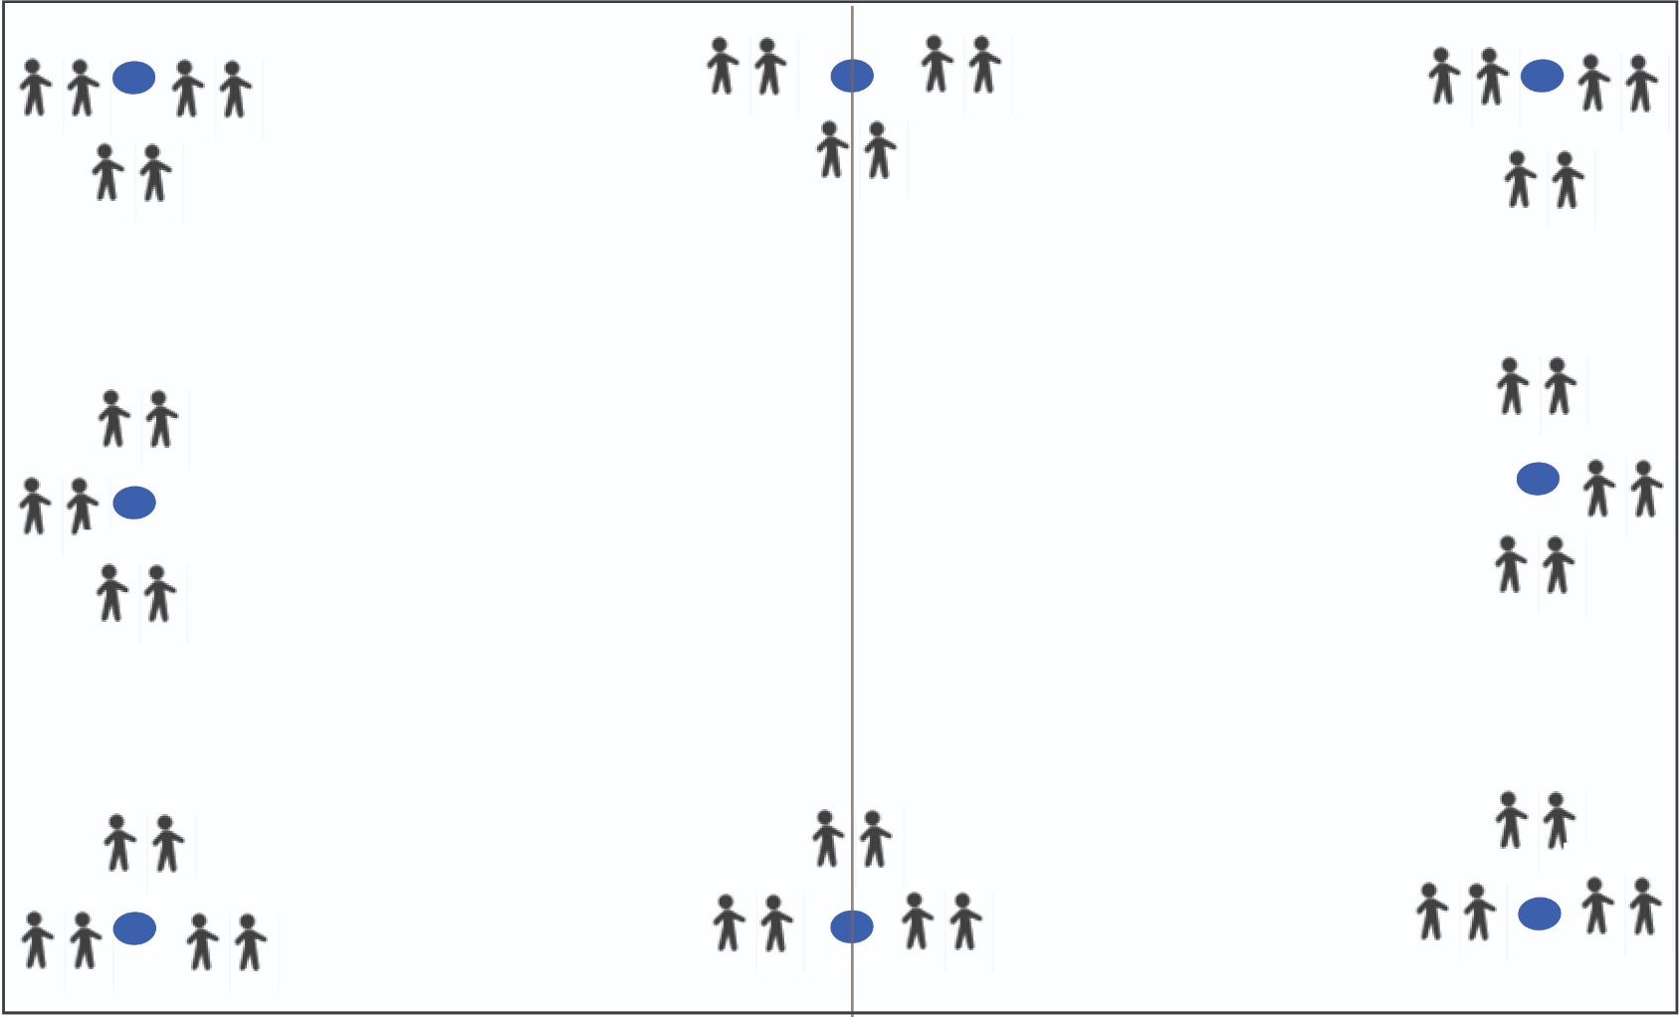

**Teacher Preparation:**

1. **Print**enough of PE Supplement - Week 2, Activity 5 - Peer Interview for each student to receive one copy.

*\*Tip: If you have students write on scratch paper, you will only need to make a class set.*

**Description:**

1. **Distribute** a copy of the[PE Supplement - Week 2, Activity 4 - Peer Interview  to each student](https://digitalcatchdirectuploads.s3-us-west-2.amazonaws.com/thinkific/cmb/9th-12th+PE+Supplement+-+Week+2%2C+Activty+4+-+Peer+Interview.pdf)
2. **Explain** that when the whistle blows you will run and find a partner and get toe-to-toe with them.

* You will ask a partner one question on this handout and record their answer.
* They will ask you the same question and record your answer.
* When you are done recording your answers, complete the physical activity listed on your interview guide (squats, push-ups, high knees, etc.)
* When the whistle blows, you will run and get toe-to-toe with a new partner and repeat the process until all questions are answered.

*Note to teachers: if time permits, your students can repeat the activity so that they have interviewed 2-3 of their peers per question.*

**Now Try This:**

1. **Instruct**students to stay with their last partner and take a seat
2. **Read** an interview question aloud to the group

* One person from each pair will stand up and the teacher will call on one to share an answer.
* The other partner will do crunches (or another activity) while the responses are read aloud.

**Activity 6: Refusal Skills Relay**

**Estimated Time:**15 minutes

**Materials:**None.

**Organization:**Students are lined up in groups on either side of the gym facing the center line.

**CASEL Competencies Covered**

* Self-awareness - accurate self-perception, self-confidence
* Social awareness - perspective-taking, respect for others
* Relationship skills - communication, social engagement, relationship-building
* Responsible decision-making - evaluating, reflecting, ethical responsibility

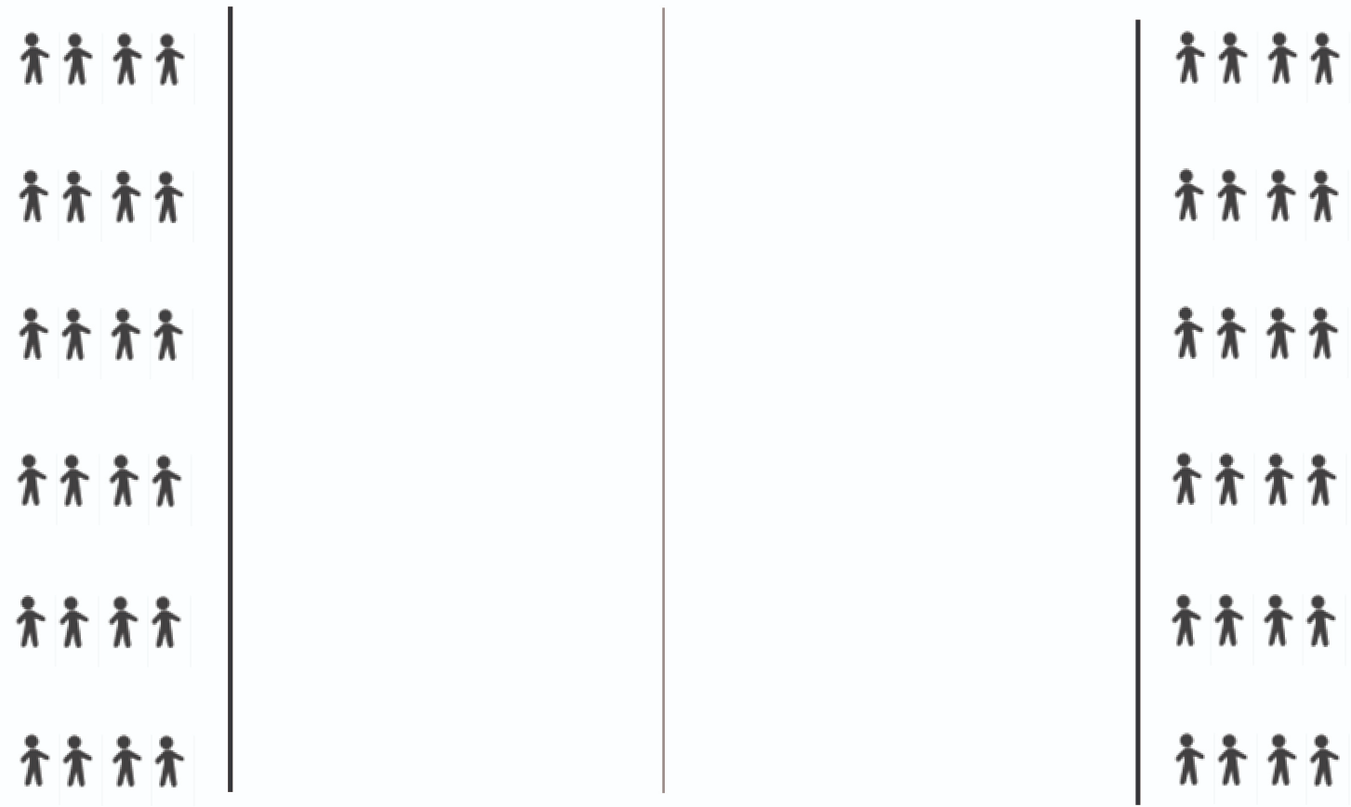

**Teacher Preparation:**

None.

**Description:**

1. **Divide** the class into groups of 6-8 students (depending on class size).
2. **Instruct** each group to form a single-file line on either side of the gym facing the center line for a relay.
3. **Explain** each person in line will need to get a sample refusal from the buckets behind you. The first person in line will run to the middle of the gym and meet toe-to-toe with the person from the line on the other side.

* You will take turns offering each other an e-cigarette and giving the refusal skill listed on the paper.
* After you each refuse each other, run back to your starting line and place the sample skill back in the bucket.
* The next time you are at the front of the line you will run to the center and get toe-to-toe with your partner.
* You will create your own refusal to an e-cigarette and take turns offering and refusing e-cigarettes.
* Repeat this process until each person has had three turns with their own refusal.
* The group members waiting for their turn will do squats, arm pumps, or march in place until it is your turn.

1. **Discuss:** What were some of the best refusals your group heard? In what situations might you need to use these refusals?
2. **Explain:** Most e-cigarette smokers mistakenly think that e-cigarettes are totally harmless. Remember, those who use e-cigarettes probably do not have the same information you do about how harmful they are. Do not put them down for using e-cigarettes. Share the information instead!

**Activity 7: Warning Labels Gallery Walk**

**Estimated Time:** 25-30 minutes

**Materials:**

* [PE Supplement - Week 3, Activity 6 - Warning Labels Gallery Walk](https://digitalcatchdirectuploads.s3-us-west-2.amazonaws.com/thinkific/cmb/9th-12th+PE+Supplement+-+Gallery+Walk.pdf)
* Tape

**Organization:** Students will walk laps around the gym looking at each warning label and image and decide which image and text is most effective.

**CASEL Competencies Covered**

* Relationship skills - communication, social engagement, relationship building, teamwork
* Self-awareness - identifying emotions, accurate self-perceptions
* Social awareness - perspective-taking, respect for others

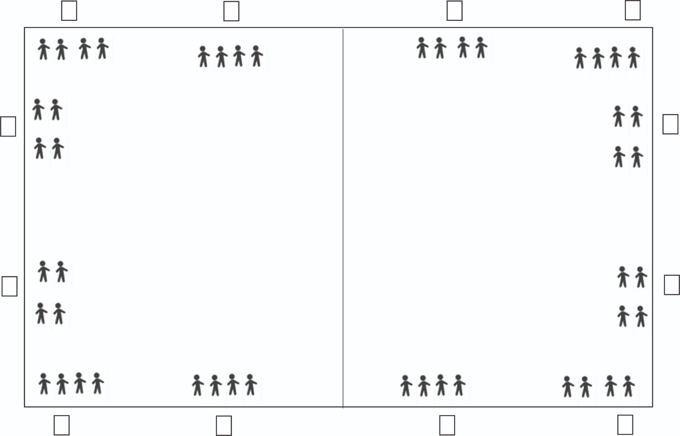

**Teacher Preparation:**

1. **Print** the example warning labels and images from the [PE Supplement - Week 3, Activity 6 - Warning Labels Gallery Walk](https://digitalcatchdirectuploads.s3-us-west-2.amazonaws.com/thinkific/cmb/9th-12th+PE+Supplement+-+Gallery+Walk.pdf)
2. **Tape** the warning labels and images around the gym, with the corresponding appeals.

**Description:**

1. **Explain** the Food and Drug Administration (FDA) has many rules for packaging and warning labels for all tobacco products, including e-cigarettes. Below is a chart to help you better understand what warning statements are required to be on these products. 

* [Labeling and Warning Statements for Tobacco Products](https://www.fda.gov/tobacco-products/products-guidance-regulations/labeling-and-warning-statements-tobacco-products)
* [The Facts on the FDA's New Tobacco Rule](https://www.fda.gov/consumers/consumer-updates/facts-fdas-new-tobacco-rule)

1. **Explain:** You will walk around the gym clockwise two times and look at each warning label picture. Consider the following as you look at each warning label:

* How does this warning label affect your thoughts about using e-cigarettes?
* What age group do you feel this warning label is meant for?
* Does this warning label help prevent youth from using e-cigarettes?
* Pay close attention to each warning label, as you will have to remember them in the next portion of this activity.
* When the whistle blows, you will walk counter-clockwise around the gym twice, looking at the warning labels again.
* When you have finished looking at all the warning labels, report to the center of the gym and form a circle.

**Now Try This:**

1. **Explain:**High step to the warning label that you believe is most effective in preventing youth use of e-cigarettes and do jumping jacks once you arrive at the warning label.
2. **Ask**a volunteer at the first warning label to explain why he or she feels that it is the most effective in preventing youth from using e-cigarettes.

*Note to teachers: There are not right or wrong answers with this activity.*

1. **Continue** until each warning label has been reviewed.

**Activity 8: True/False**

**Estimated Time:**10-15 minutes

**Equipment:** n/a

**Organization:**Students are lined up around the perimeter of the gym.

**CASEL Competencies Covered**

* Self-awareness - accurate self-perception, self-confidence
* Social awareness - perspective-taking, respect for others
* Relationship skills - communication, social engagement, relationship-building
* Responsible decision-making - evaluating, reflecting, ethical responsibility

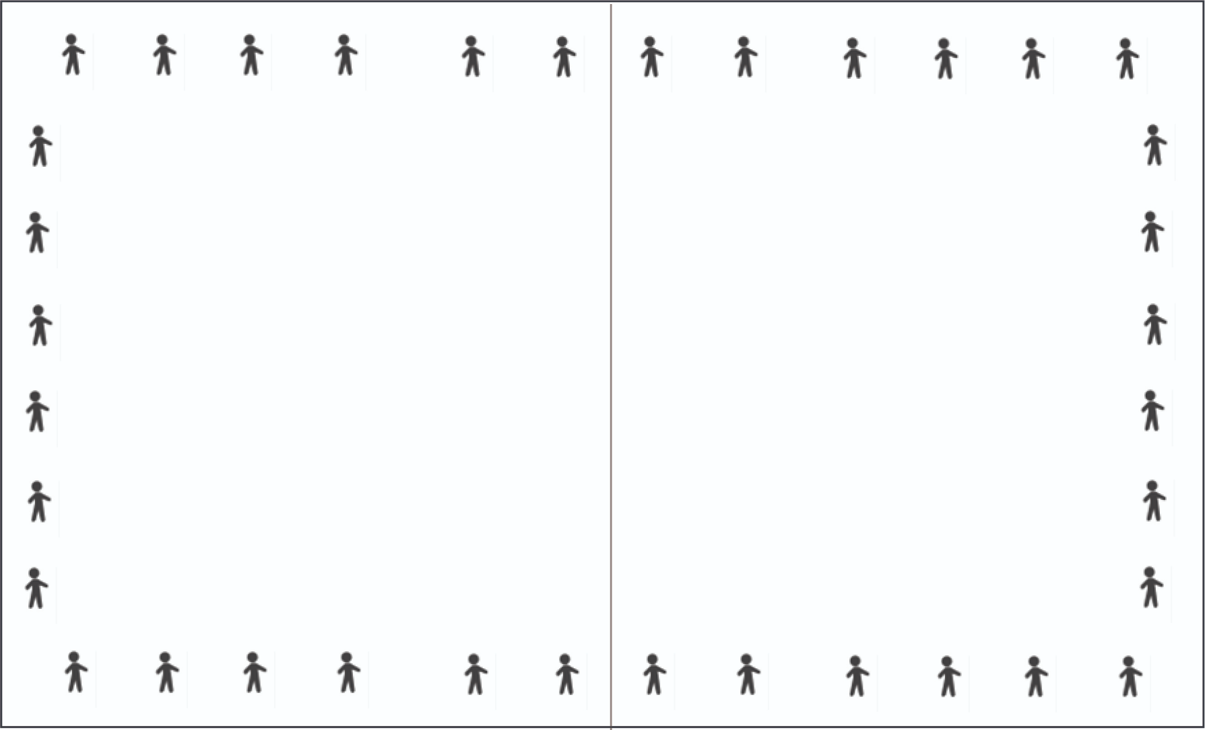

**Teacher Preparation**

None.

**Description:**

1. **Explain:** We are going to play a true/false game. After each statement:

* If you think the statement is “true”, march in place.
* If you think the statement is “false” do jumping jacks in place (Emphasize that guessing is okay).

1. **Read** each statement out loud.
2. **Reveal** the correct answer once all students are performing an activity.
3. The “smoke” that comes out of E-cigarettes is harmless water vapor.

* **False:** It is an aerosol, or fine spray, of toxins and nicotine.

1. Almost all e-cigarettes contain nicotine, with some brands containing more nicotine than a conventional cigarette.

* **True:** nearly all E-cigarettes contain nicotine, even the flavored ones.

1. Cigarettes, E-cigarettes, hookah, cigars, heat not burn, every form of tobacco products can cause harm to nearly every organ in your body.

* **True**: Nicotine causes harm to many organs in the body including brain, lungs, heart, Gastrointestinal tract, joint issues.

1. The most popular brand of e-cigarette is JUUL contains 59 mg/ml (or 5% by weight) of nicotine.

* **True:** JUUL is the most popular brand of e-cigarette containing 59 mg/ml of nicotine that holds over 70% of the e-cigarette market share.

1. E-cigarettes contain fewer toxic chemicals than conventional cigarettes.

* **True:**E-cigarettes do have fewer toxic chemicals than conventional cigarettes, but E-cigarettes still contain nicotine and other toxins.

1. It is safe for women to use a nicotine product (including e-cigarettes) when pregnant.

* **False**: Nicotine can cause a number of birth complications and babies who were exposed to nicotine in utero tend to grow up to have poor long term academic performance and behavioral problems such as ADHD, aggressive behaviors, and future substance abuse.

1. There are no negative social consequences of using e-cigarettes.

* **False:** There are several negative consequences from using e-cigarettes including expensive habit, get suspended from sports, bad role model for younger family members, trouble with the law (legal age of purchase 18 or 21 depending on your state), lose trust of parents and get in trouble if caught using at school.

1. E-liquid is highly toxic and can even be fatal to anyone who swallows it.

* **True:** across the U.S. there are hundreds of calls placed to poison control centers each month due to people drinking e-liquid.

1. Teenagers become addicted to nicotine easier than adults.

* **True:** Developing brains are more sensitive to the addictive nature of nicotine.

1. Young people who use e-cigarettes are less likely to use conventional cigarettes in the future.

* **False:** Young people who use e-cigarettes are FOUR TIMES as likely to start using conventional cigarettes within 18 months as those who do not use e-cigarettes at all.

1. Using e-cigarettes is a gateway to combustible tobacco, alcohol and marijuana and other addictive drugs.

* **True:** When you smoke a tobacco product, nicotine gets into the blood through the lungs, then travels to the brain where it hacks into the brain by pretending to be a natural brain chemical. It then activates the dopamine reward system (which is responsible for pleasure) in the brain. Overstimulation of this pleasure system in the brain leads to addiction.

1. Approximately two-thirds of teens don’t think JUUL contains nicotine.

* **True:** In a survey conducted by the Truth Initiative 63% of JUUL users surveyed stated they did not know JUUL contained nicotine.

1. Fruit and candy flavored e-cigarettes do not contain nicotine.

* **False:** 99% of all e-cigarettes and all JUUL contain nicotine no matter what the flavor.

1. There is no help for teenagers who want to quit using e-cigarettes or JUUL.

* **False:** There are several resources including:
  1. FDA-approved cessation products (1-800-QUIT NOW), a text-based program (text QUIT to 47848).
  2. Centers for Disease Control and Prevention, Youth Tobacco Prevention. [www.cdc.gov/tobacco/youth/index.htm.](http://www.cdc.gov/tobacco/youth/index.htm.)
  3. Teens in nine states -- Colorado, Massachusetts, Michigan, Montana, North Dakota, Nevada, Ohio, Pennsylvania and Utah -- can call or text the helpline at 1-855-891-9989 or go online to  [mylifemyquit.com](https://mylifemyquit.com/).

1. E-cigarettes don’t affect your athletic performance.

* **False:** E-cigarette contain toxins that are known to damage lungs, plus nicotine which weakens heart health.