Physical Education Supplement
This PE supplement is an active addition to CATCH My Breath that was designed to reinforce learning objectives in an active physical education setting. The following activities are intended to be used for grades 5-8 in addition to CATCH My Breath classroom sessions. The program can be taught at anytime of the year, however you may consider implementing the program in the fall during school-wide tobacco, alcohol and drug awareness campaigns. This supplement can also be used and adapted to a traditional classroom setting if desired and time permits.
It is recommended that the CATCH My Breath PE Supplement be used in successive PE periods until each activity is completed. Each activity is meant to be taught in the order presented. Although PE class times vary at each campus, the PE Supplement was designed on a weekly 50-minute class and the following sequence is suggested:
- Week 1: Activities 1, 2, and 3
  - Recommended to be taught in conjunction with CATCH My Breath Session 1
- Week 2: Activities 4, 5, and 6
  - Recommended to be taught in conjunction with CATCH My Breath Session 2
- Week 3: Activities 7, 8, and 9
  - Recommended to be taught in conjunction with CATCH My Breath Session 3

Activity 1: Walk and Talk Warm Up
Estimated time: 5 minutes
Materials: None
Organization: Students walk the perimeter of the gym in pairs.
CASEL Competencies Covered
- Relationship skills - communication, social engagement, relationship building, teamwork
- Self-awareness - identifying emotions, accurate self-perceptions
- Social awareness - perspective-taking, respect for others

Teacher Preparation: None

Description:
- As students enter the gym, greet them at the door and ask them to put their belongings down, and begin to walk the perimeter of the gym.
- When all of the students are in the gym, tell them to quickly find a partner and walk the perimeter of the gym with that person..
- Ask the students to share with their partner either what they know about e-cigarettes or a question they have about e-cigarettes as they walk the perimeter.
- Tell the students to take a seat, and then have a few volunteers share what they know or share a question they have about e-cigarettes.

Activity 2: Gathering the Evidence
Estimated Time: 25-30 minutes
Materials:
- PE Supplement - Week 1, Activity 2 - Ingredient Cards
- PE Supplement - Week 1, Activity 2 - Notes Sheet
- 6 bins or buckets.
- One clipboard per group with writing utensil and scratch paper attached.
- A white board or butcher paper on which the teacher will write the ingredients and corresponding fitness activities (see below).
Note to teachers: If you do not have clipboards available, have students bring their notebooks to class, or use the wall/floor as a hard surface to write on.
Organization: Students are lined up in groups of six to eight (depending on class size) on either side of the gym with 6 dedicated stations in the middle of the gym (similar to the example image below). Clipboard will be given to the last student in line to start.
CASEL Competencies Covered
- Social awareness - perspective-taking, respect for others
- Relationship skills - communication, social engagement
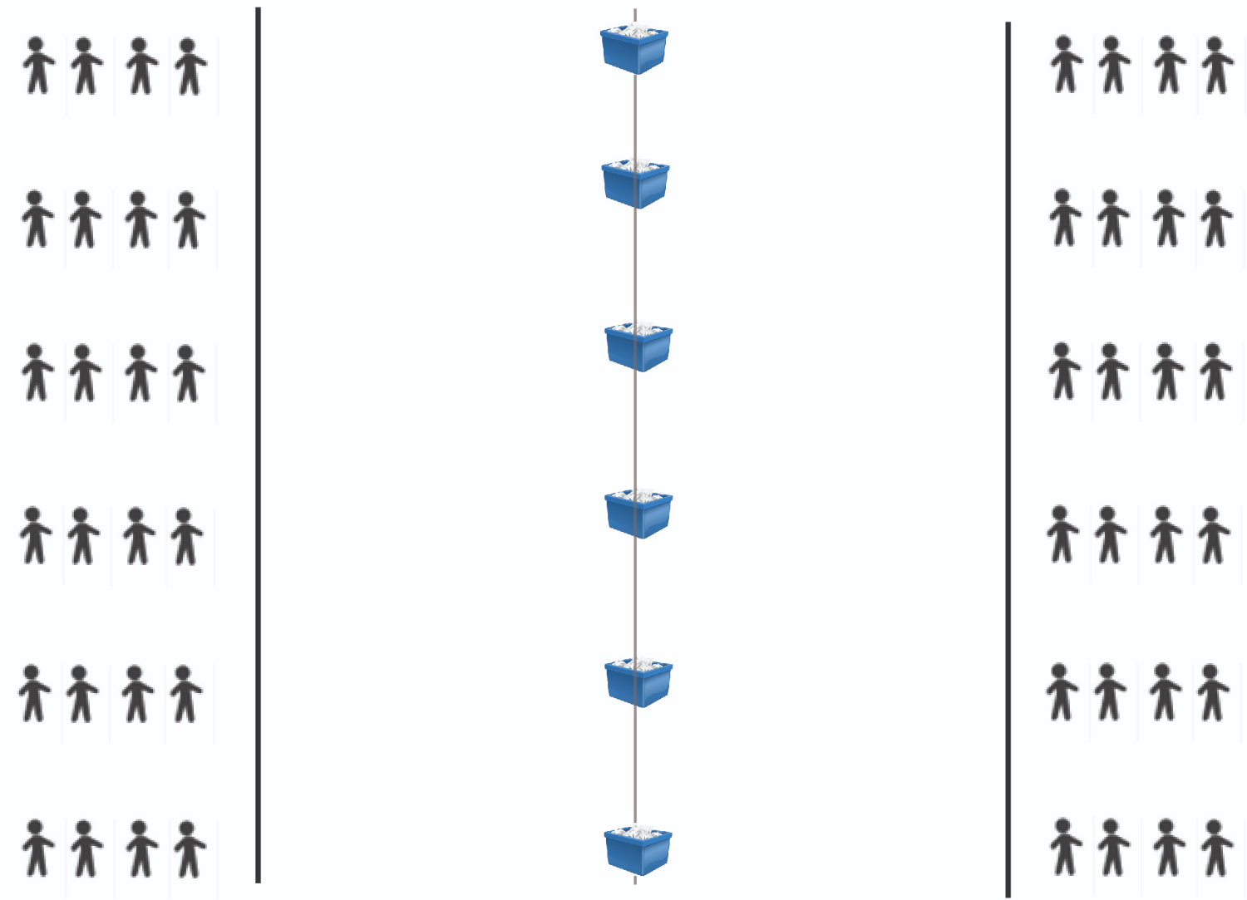

Teacher Preparation:
- Print out the PE Supplement - Week 1, Activity 2 - Ingredient Cards and make enough copies for each bucket to have at least three or four copies of each card in the bucket.
- Print the PE Supplement - Week 1, Activity 2 - Notes Sheet. Make enough copies for each group of about 4 students to receive one.
*Tip: If students write on scratch paper, you only need to make one class set.
- Prepare one clipboard per group with a handout and attached writing utensil. Place scratch paper in the clipboard or ask students to bring scratch paper if you would like to re-use handouts with multiple classes.
- Cut out each sheet of cards and place each set into one of 6 bins lined up across the center of the gym. Fold the cards to make them easier for students to pick up.
- Prepare and display a white board or butcher paper with the following:
- JUUL: jumping jacks
- Nicotine: high steps
- Propylene Glycol: hop in place
- Some of 8,000+ flavoring ingredients: squats
- Addiction: march in place
- Aerosol: standing oblique crunches (stand up with your heels together and your toes pointed outward. Extend one arm straight up above your head and place the other hand on your waist for balance. Bring your elbow and knee together, then return to the starting position)
- Toxic Chemical: calf raises (raise heels off the floor, then slowly lower them)
- Formaldehyde: arm pumps (pump both of your arms over your head)
Note to teachers: It is okay to modify these activities to fit the physical ability of your students or a skills unit in your class (e.g. volleyball or basketball skills drills, etc.)
Tip: To encourage students to stay active during the “rest” periods, award points to the most active or the team that cheers the most.

Description:
- Explain: E-cigarettes are an alternative to smoking combustible cigarettes and there is a lot of misleading information out there being spread by e-cigarette and tobacco companies. We are going to investigate the ingredients ourselves to find out the truth.
- Divide students into groups of four and have them line up on either side of the gym facing one of the six baskets in the center.
- Give each group one clipboard with attached writing utensil, blank E-cigarette Ingredient handout, and scratch paper (optional). The last student in line will start with the clipboard.
- Explain: In the center of the gym are baskets containing E-cigarette Ingredient Cards. The first person in line will sprint to the basket, grab a card, sprint back to the group and read it aloud to the group.
- The student with the card then takes the card to the back of the line to take notes on the group sheet.
- The next person will sprint to the basket in the center of the gym to retrieve a new card.
- If you are not retrieving a card or taking notes, you will march in place.
- The group will continue taking turns retrieving and reading ingredient cards until you have the information for all cards recorded.
Note: It is alright if a student brings back a card that the group has already recorded, as the recorder may have missed information the first time around.

Now Try This:
- Instruct students to remain in their groups once all the groups have finished collecting information.
- Explain: I will read out information on an ingredient. Use the notes your group took to determine which ingredient I am reading about. Then, perform the action assigned to each ingredient in place until I call out the next ingredient.
- JUUL: jumping jacks
- Nicotine: high steps
- Propylene Glycol: hop in place
- Some of 8,000+ flavoring ingredients: squats
- Addiction: march in place
- Aerosol: standing oblique crunches
- Toxic Chemical: calf raises
- Formaldehyde: arm pumps
- Demonstrate actions, if needed, then begin calling out ingredient definitions until all are completed.

Activity 3: Social Norms
Estimated Time: 10 minutes
Materials: None
Organization: Students are lined up on one side of the gym as the baseline or “0%”.

Description:
- Instruct all students to start on the 0% line (or baseline)
- Practice running to each cut point and explain that when the whistle blows, the students will jog to the 25% line and do five jumping jacks. This will repeat for the 50%, 75%, and 100% lines as well.
- Explain that you will ask a question and the students must jog to the spot in the gym that corresponds with their guess.
- Once a student gets to their spot, they will march in place until the teacher reveals the answer.
- Ask students “What percentage of middle school students have used an e-cigarette in the last 30 days?”
- Remind students to march in place until you reveal the answer.
- Reveal the true percentage of 4.9%.
- Ask a volunteer to move to that spot in the gym.
- Instruct students to return to the 0% line (or baseline)
- Ask students “What percentage of high school students have used an e-cigarette in the last 30 days?”
- Remind students they will jog to the spot in the gym that corresponds with their guess and march in place until you reveal the answer.
- Reveal the true percentage of 20.8% percent.
- Ask a volunteer to move to that spot in the gym.
- Ask students to take a seat in their current position.
- Discuss: Were these percentages surprising? Why might most of us have thought that the number was higher?
- Explain: Most students do NOT use e-cigarettes. It is the all the advertising that makes it seem like more people use e-cigarettes then really do.

Activity 4: Walk and Talk Warm Up
Estimated time: 5 minutes
Materials: None

Organization: Students walk the perimeter of the gym in pairs.

CASEL Competencies Covered:
- Relationship skills - communication, social engagement, relationship building, teamwork
- Self-awareness - identifying emotions, accurate self-perceptions
- Social awareness - perspective-taking, respect for others

Teacher Preparation:
None

Description:

- As students enter the gym, greet them at the door and ask them to put their belongings down, get a pencil out of their bookbag, and begin to walk the perimeter of the gym.
- When all of the students are in the gym, tell them to quickly find a partner and walk the perimeter of the gym with that person.
- Ask the students to share with their partner one thing they learned last session about E-cigarette ingredients as they walk the perimeter of the gym.
- Tell the students to go to their seats, and then have a few volunteers share what they learned.

Activity 5: Peer Interviews
Estimated Time: 25-30 minutes
Materials:
- PE Supplement - Week 2, Activity 5 - Peer Interview
- Pencils (Students can use their own)
- Whistle
- Clipboards or students’ own binders/notebooks
Organization: Students will pair-off toe-to-toe with a partner and ask a question, complete the assigned physical activity, and then find a new partner.
CASEL Competencies Covered
- Self management - self-motivation, self-discipline
- Social awareness - empathy, perspective-taking, respect for others
- Relationship skills - social engagement, communication, teamwork
- Responsible decision-making - analyzing situations, evaluating, reflecting
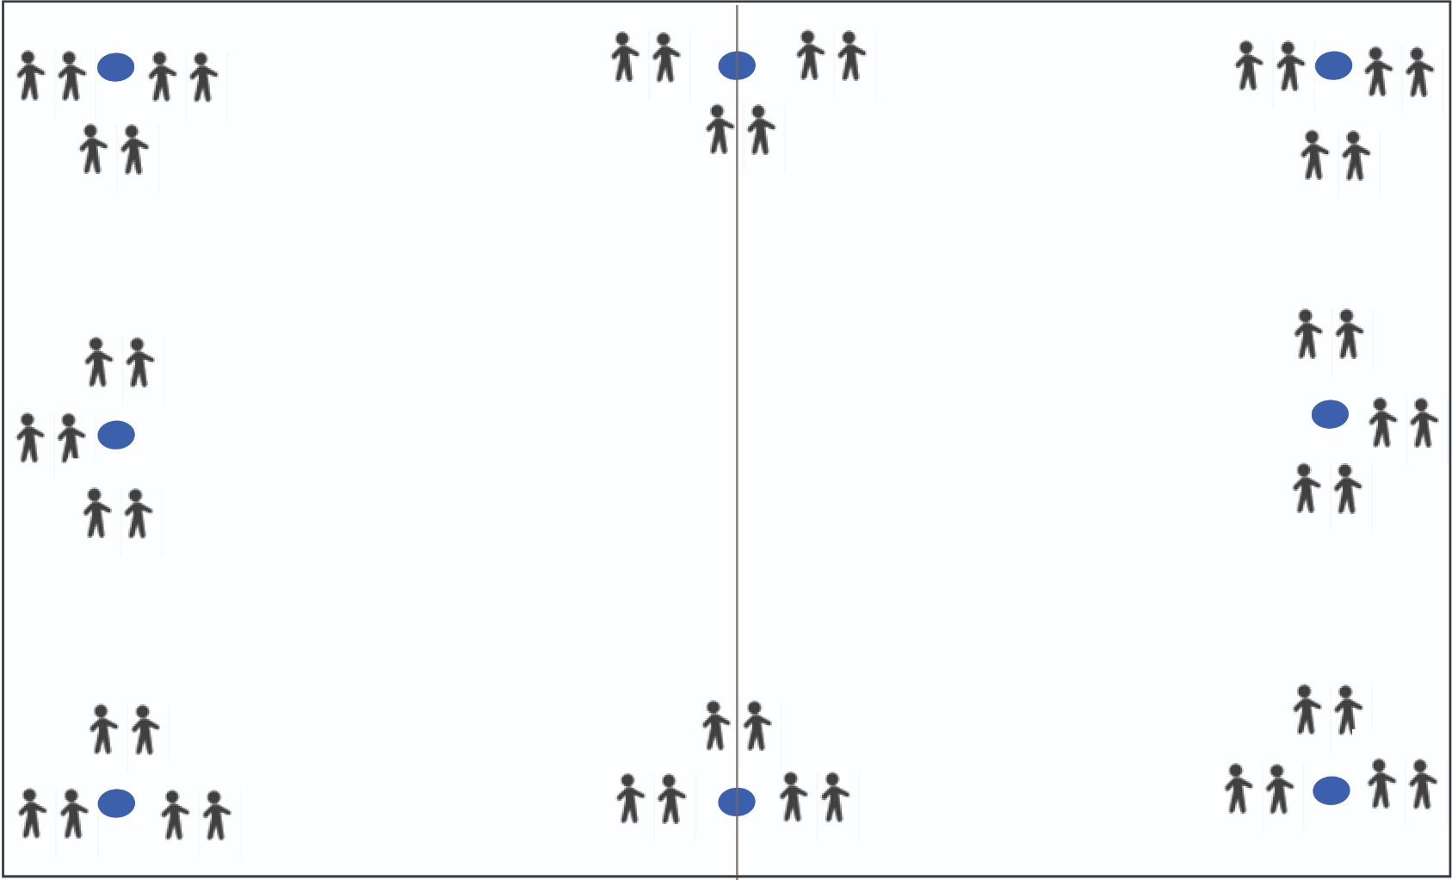

Teacher Preparation:
- Print enough of PE Supplement - Week 2, Activity 5 - Peer Interview for each student to receive one copy.
*Tip: If you have students write on scratch paper, you will only need to make a class set.

Description:
- Distribute a copy of the PE Supplement - Week 2, Activity 5 - Peer Interviewto each student
- Explain that when the whistle blows you will run and find a partner and get toe-to-toe with them.
- You will ask a partner one question on this handout and record their answer.
- They will ask you the same question and record your answer.
- When you are done recording your answers, complete the physical activity listed on your interview guide (squats, push-ups, high knees, etc.)
- When the physical activity is complete and you have the initials of your partner, run to find a new partner. If you cannot find a new partner right away, march in place until you find one.
Note to teachers: if time permits, your students can repeat the activity so that they have interviewed 2-3 of their peers per question.

Now Try This:
- Instruct students to stay with their last partner and take a seat
- Read an interview question aloud to the group
- One person from each pair will stand up and the teacher will call on one to share an answer.
- The other partner will do crunches (or another activity) while the responses are read aloud.

Activity 6: Refusal Skills Relay
Estimated Time: 15 minutes
Materials: None.
Organization: Students are lined up in groups on either side of the gym facing the center line.
CASEL Competencies Covered
- Self-awareness - accurate self-perception, self-confidence
- Social awareness - perspective-taking, respect for others
- Relationship skills - communication, social engagement, relationship-building
- Responsible decision-making - evaluating, reflecting, ethical responsibility

Teacher Preparation:
None.

Description:
- Divide the class into groups of 6-8 students (depending on class size).
- Instruct each group to form a single-file line on either side of the gym facing the center line for a relay.
- Explain each person in line will need to get a sample refusal from the buckets behind you. The first person in line will run to the middle of the gym and meet toe-to-toe with the person from the line on the other side.
- You will take turns offering each other an e-cigarette and giving the refusal skill listed on the paper.
- After you each refuse each other, run back to your starting line and place the sample skill back in the bucket.
- The next time you are at the front of the line you will run to the center and get toe-to-toe with your partner.
- You will create your own refusal to an e-cigarette and take turns offering and refusing e-cigarettes.
- Repeat this process until each person has had three turns with their own refusal.
- The group members waiting for their turn will do squats, arm pumps, or march in place until it is your turn.
- Discuss: What were some of the best refusals your group heard? In what situations might you need to use these refusals?
- Explain: Most e-cigarette smokers mistakenly think that e-cigarettes are totally harmless. Remember, those who use e-cigarettes probably do not have the same information you do about how harmful they are. Do not put them down for using e-cigarettes. Share the information instead!

Activity 7: Advertising Gallery Walk
Estimated Time: 25-30 minutes
Materials:
- PE Supplement - Week 3, Activity 7 - Advertising Gallery Walk - Example Ads
- PE Supplement - Week 3, Activity 7 - Advertising Gallery Walk - Appeals
- Tape
Note to teachers: You do not need to print out all of the ads for this activity. Select the top 5 or 6 that best related to the ages of students you teach.
Organization: Students will walk laps around the gym looking at each ad and the associated appeals as they go.
CASEL Competencies Covered
- Relationship skills - communication, social engagement, relationship building, teamwork
- Self-awareness - identifying emotions, accurate self-perceptions
- Social awareness - perspective-taking, respect for others
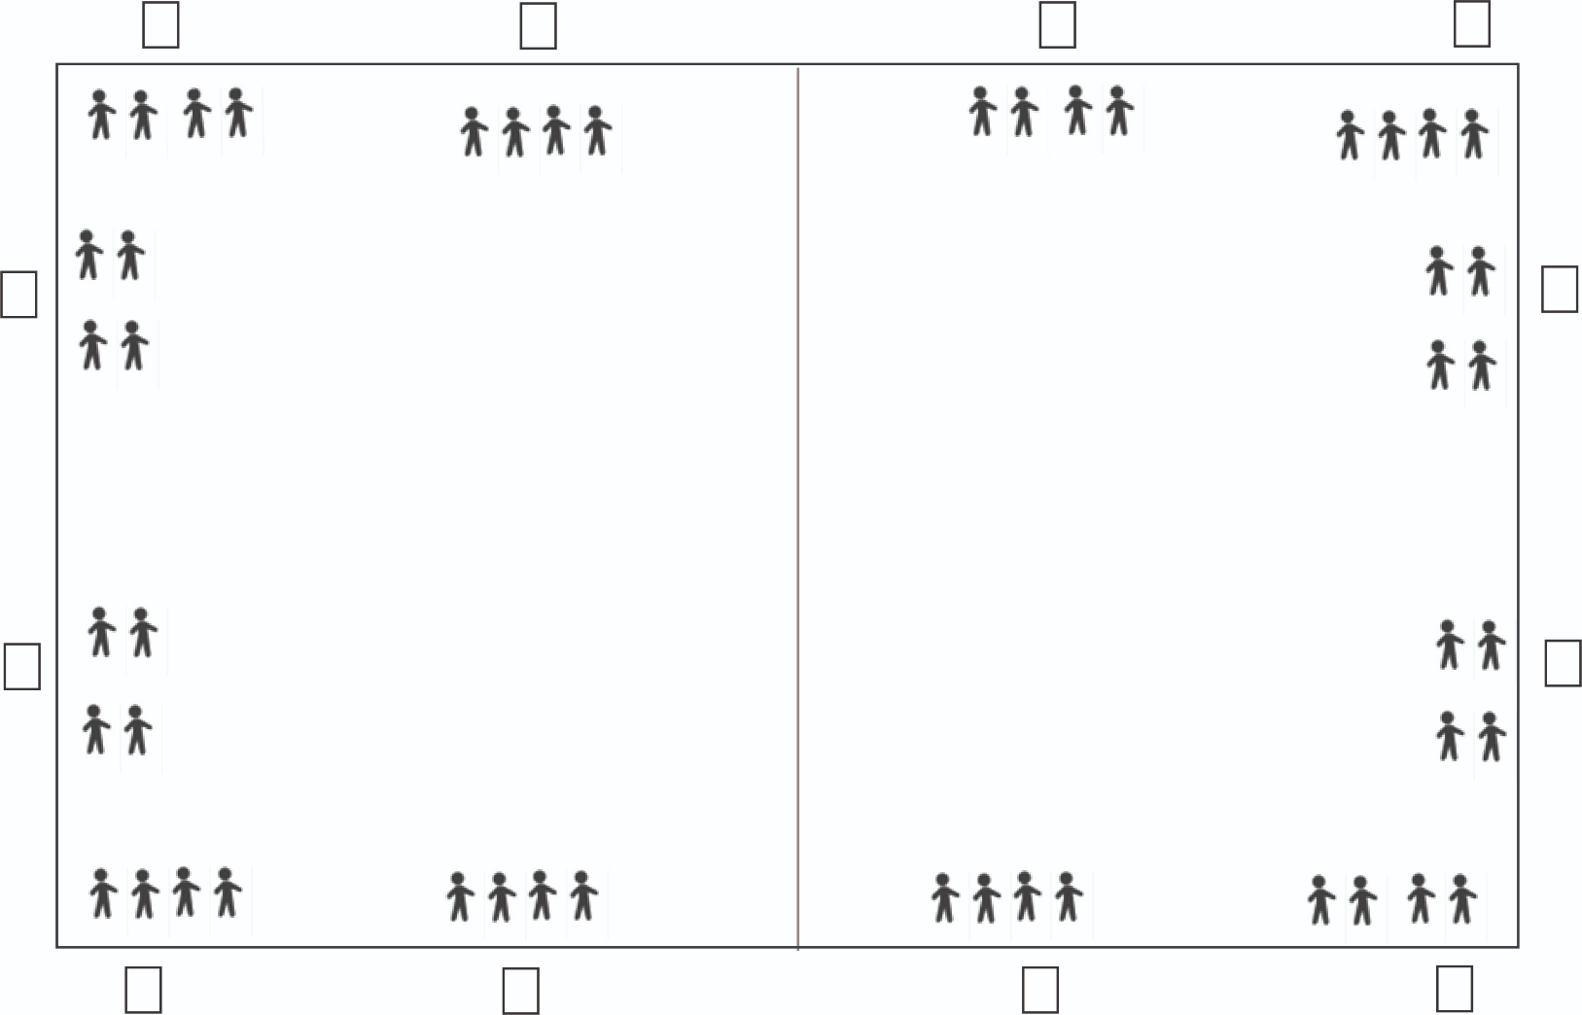

Teacher Preparation:
- Print the example advertisements from the PE Supplement - Week 3, Activity 7 - Advertising Gallery Walk - Example Ads
- Print enough of page 1 of PE Supplement - Week 3, Activity 7 - Advertising Gallery Walk - Appealsfor each student to receive a copy and enough of page 2 of PE Supplement - Week 3, Activity 7 - Advertising Gallery Walk - Appealsfor each ad to receive the correct number of appeals.
- Tape the advertisements around the gym, with the corresponding appeals.
Note to teachers: Using 5 ads is recommended for this activity. More have been included to leave it to instructors to decide on the best ads for the student population.

Description:
- Explain background information: E-cigarette companies, like many others, use two types of advertising to get people to buy their products:
- Direct advertising: obviously paid for by the tobacco and e-cigarette industry ex: billboards, TV ads, internet banner ads, radio ads, magazine ads.
- Indirect advertising: hides that it’s an ad. The following are different mediums that use indirect advertising:
  - Social Media: Big tobacco companies pay people to post about tobacco and e-cigarettes to glamorize and make them look “cool”, fun, social, delicious.
  - Movies/Television: Tobacco and e-cigarette companies pay actors to smoke their brands in movies/television.
  - Magazines/Newspapers: Some magazines choose to take money from the tobacco and e-cigarette industry to promote products as part of a glamorous lifestyle.
- In addition to these types of advertising, e-cigarette companies, and many others, use something called an appeal to grab your attention and persuade you to buy something. The following are common appeals used in the e-cigarette industry:
  - Health- using the product will help you live a healthier lifestyle or be a healthier person.
  - Flavor - the product tastes good so therefore it is safe for you to use.
  - Social Life - using the product will help you feel more included, respected, and accepted by your friends and other people you might want to be friends with.
  - Celebrity - using or buying this product will make you more like your favorite celebrity or movie star OR you could see a celebrity using the product and because they use it, you feel it is safe and okay for you to use as well.
  - Freedom - the idea that using their product will allow you to be free.
  - Sports - if you use the product, you will be better at sports, and more like your favorite professional athletes you could see a sports star using the product and because they use it, you feel it is safe and okay for you to use as well.
  - Masculinity/Femininity - this gets at the idea that you might want to be a perfect boy or girl. They want you to think that if you use their product you will be more attractive and liked by other people.
  - Glamour/Beauty - these products appear to be perfect and will help you get to that stage too.
- Explain: You will walk around the gym clockwise two times and look at each advertisement and the appeals next to it on the wall. Consider the following as you look at each ad:
- Is it direct or indirect?
- Does this ad appeal to you?
- Pay close attention to each ad, as you will have to remember them in the next portion of this activity.
- When the whistle blows, you will walk counter-clockwise around the gym twice, looking at the ads again.
- When you have finished looking at all the ads, report to the center of the gym and form a circle.

Now Try This:
- Explain: I am going to call out an advertising appeal. High step to the advertisement that you believe is using that appeal and do jumping jacks once you arrive at the ad.
- Call out the first appeal and wait for students to get to the correct ad(s)
- Ask a volunteer to give the definition of the appeal that the ad uses and determine whether it is an indirect or direct ad.
Note to teachers: If time allows, you can also ask students if the ad appeals to them and why.
- Continue until each ad has been reviewed.

Activity 8: True/False
Estimated Time: 10-15 minutes
Equipment: n/a
Organization: Students are lined up around the perimeter of the gym.
CASEL Competencies Covered
- Self-awareness - accurate self-perception, self-confidence
- Social awareness - perspective-taking, respect for others
- Relationship skills - communication, social engagement, relationship-building
- Responsible decision-making - evaluating, reflecting, ethical responsibility
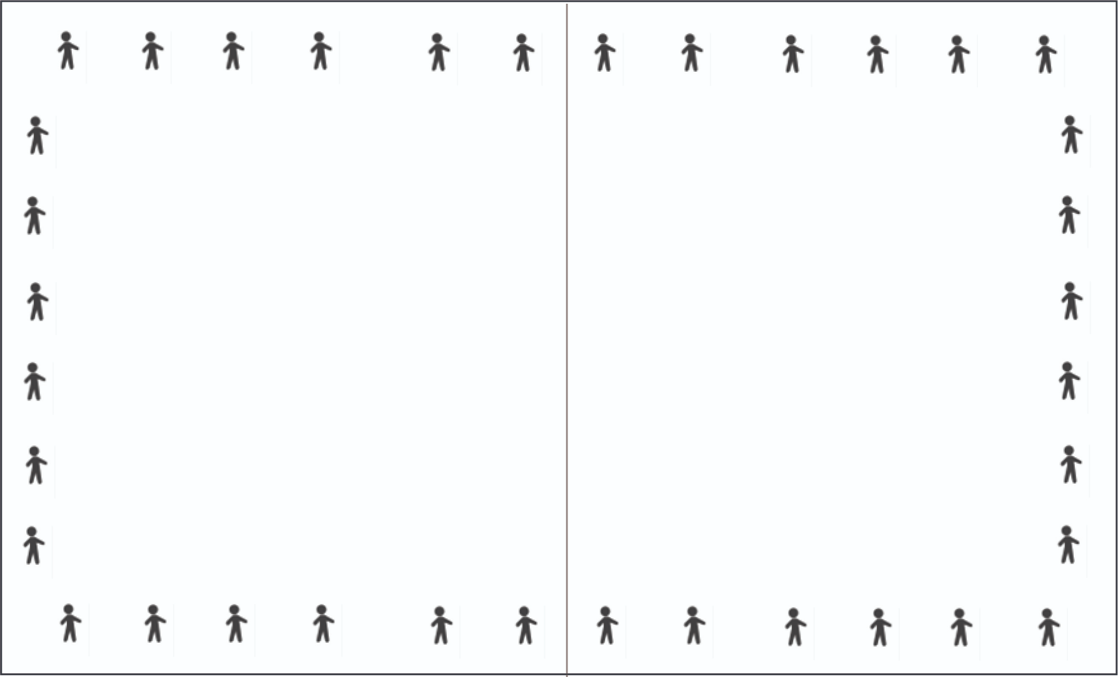

Teacher Preparation
None.

Description:
- Explain: We are going to play a true/false game. After each statement:
- If you think the statement is “true”, march in place.
- If you think the statement is “false” do jumping jacks in place (Emphasize that guessing is okay).
- Read each statement out loud.
- Reveal the correct answer once all students are performing an activity.

- The “smoke” that comes out of E-cigarettes is harmless water vapor.
- False: It is an aerosol, or fine spray, of toxins and nicotine.
- Almost all e-cigarettes contain nicotine, with some brands containing more nicotine than a conventional cigarette.
- True: nearly all E-cigarettes contain nicotine, even the flavored ones.
- Most teens smoke E-cigarettes.
- False: Nearly 80% of high school students and more than 95% of middle school students do NOT smoke E-cigarettes.
- JUUL is not an e-cigarette.
- False: JUUL is the most popular brand of e-cigarette in the United States.
- E-cigarettes contain fewer toxic chemicals than conventional cigarettes.
- True:E-cigarettes do have fewer toxic chemicals than conventional cigarettes, but E-cigarettes still contain nicotine and other toxins.
- Flavored cigarettes don’t contain nicotine.
- False: 95% of flavored e-liquid contains nicotine.
- Nicotine is nearly as addictive as coffee.
- False: nicotine is much more addictive than coffee.
- E-liquid is highly toxic and can even be fatal to anyone who swallows it.
- True: across the U.S. there are hundreds of calls placed to poison control centers each month due to people drinking e-liquid.
- Teenagers become addicted to nicotine easier than adults.
- True: Developing brains are more sensitive to the addictive nature of nicotine.
- Young people who use e-cigarettes are less likely to use conventional cigarettes in the future.
- False: Young people who use e-cigarettes are FOUR TIMES as likely to start using conventional cigarettes within 18 months as those who do not use e-cigarettes at all.
- E-cigarettes contain formaldehyde, which is used to preserve dead bodies.
- True: formaldehyde is just one of the toxic chemicals produced by e-cigarettes.
- Indirect Advertising hides the fact that it is an ad.
- True: often it is difficult to know that a company is advertising if you see a celebrity or athlete using their product.
- E-cigarette batteries are known to occasionally explode in people’s pockets or mouths.
- True: the shape and construction of e-cigarettes makes them more likely than other products with lithium-ion batteries to behave like “flaming rockets” when a battery fails.
- When polled, most teens approved of E-cigarette use.
- False: The vast majority of students polled did not think E-cigarette use was acceptable or cool.
- E-cigarettes don’t affect your athletic performance.
- False: E-cigarette contain toxins that are known to damage lungs, plus nicotine which weakens heart health.

Activity 9: Goal Setting Obstacle Course
Estimated Time: 15-20 minutes
Equipment:
- Poster Board, White Board, or Butcher Paper
- Markers or pencils
- Frisbee, cones, and/or flags
- Organization: Students are lined up in groups on one side of the gym a small group of peer facilitators in the middle of the gym and the board at the far end.
CASEL Competencies Covered
  - Self-awareness - accurate self-perception, self-confidence
  - Social awareness - perspective-taking, respect for others
  - Relationship skills - communication, social engagement, relationship-building
  - Responsible decision-making - evaluating, reflecting, ethical responsibility
- 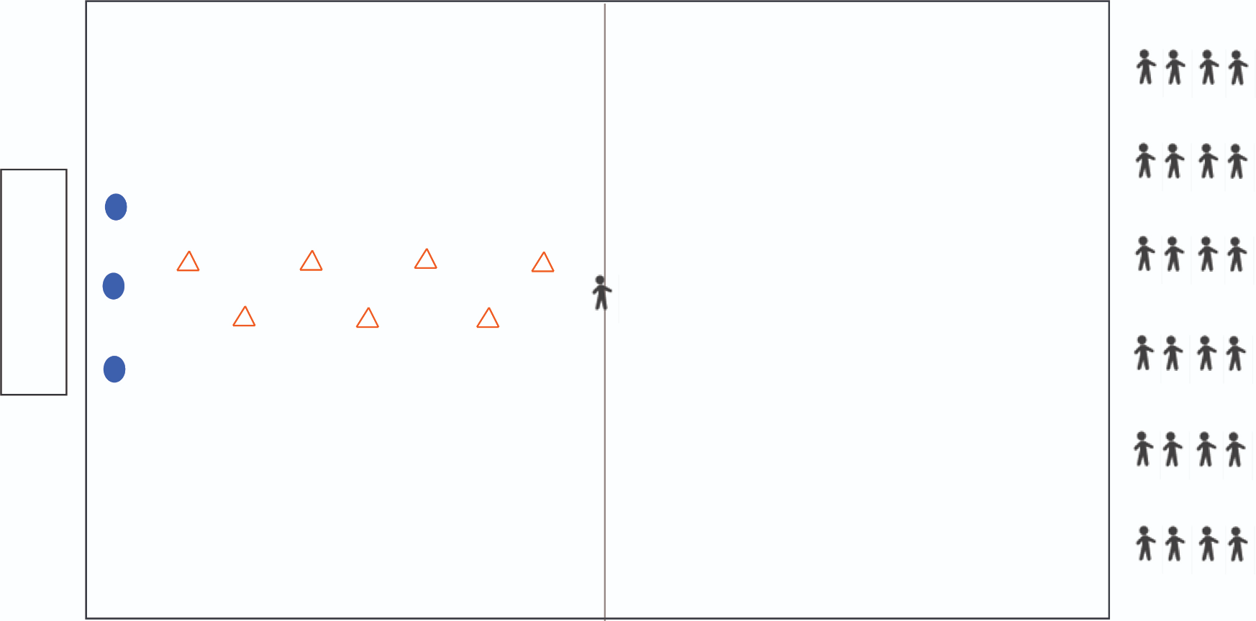

Teacher Preparation:
  - Prepare a poster, white board, or butcher paper on it with the words “Your Life, Your Choice” on it and an overturned frisbee with markers or pencils in it.
  - Use the cones to prepare an obstacle course in the gym leading up to the place where you have posted the white board/poster/butcher paper.
  - Select a group of 3-5 peer facilitators (if you have not already) to stand in the middle of the gym.
  - Explain to these facilitators that they will pretend to offer other students an e-cigarette and will await a unique refusal from the students before they can complete the obstacle course.
- Note to teachers: It is okay to modify these activities to fit the physical ability of your students or a skills unit in your class (e.g. volleyball or basketball skills drills, etc.)

Description:
  - Divide students into groups of 4 and instruct them to form lines on one side of the gym.
  - Ask the pre-selected peer leaders to move to the center of the gym.
  - Explain: We are going to practice ways to refuse e-cigarettes in case someone offers them to you.

  - Each person in your group will have a turn.
  - Before we start, think of non-aggressive ways to refuse an e-cigarette.
  - I am going to stand in the middle of the gym.
  - When I say, “Go!”, the first person in each line will do lunges to one of the peer facilitators in the middle of the gym.
  - When you get to a peer facilitator, they will pretend to offer you an e-cigarette.
  - You will then give them a unique refusal to the e-cigarette offer.
  - Once you have refused the offer in your own way, you will complete the obstacle course.
  - At the end to the board/butcher paper and sign your name with one of the writing utensils in the frisbee, signifying that you will make a smart choice regarding e-cigarettes.
  - Then, you will jog along the perimeter to rejoin your group.
  - Everyone will march in place while waiting for your turn.
  - We will play until everyone has had a chance to go.
- Note to teachers: If time allows, students can go through the course more than once and take turns being facilitators offers and refusing e-cigarettes.

